I.T.5

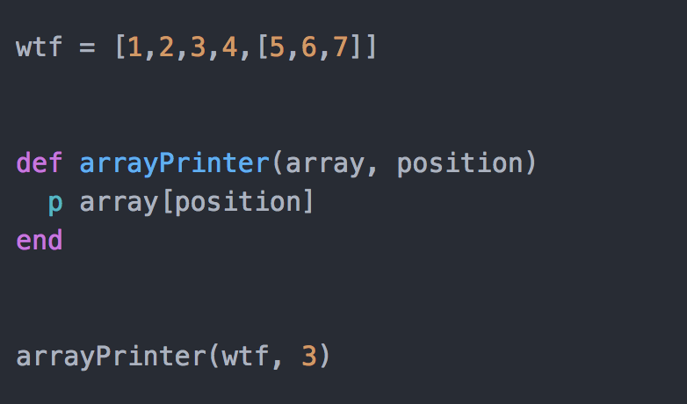
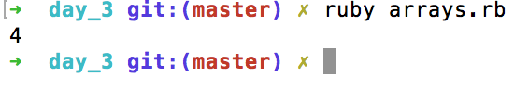

I.T.6
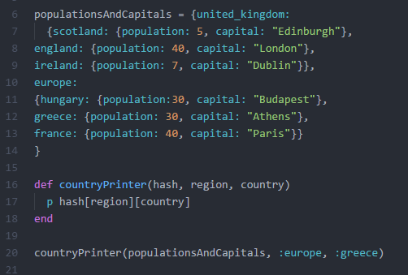
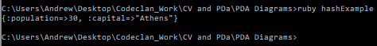

I.T 3

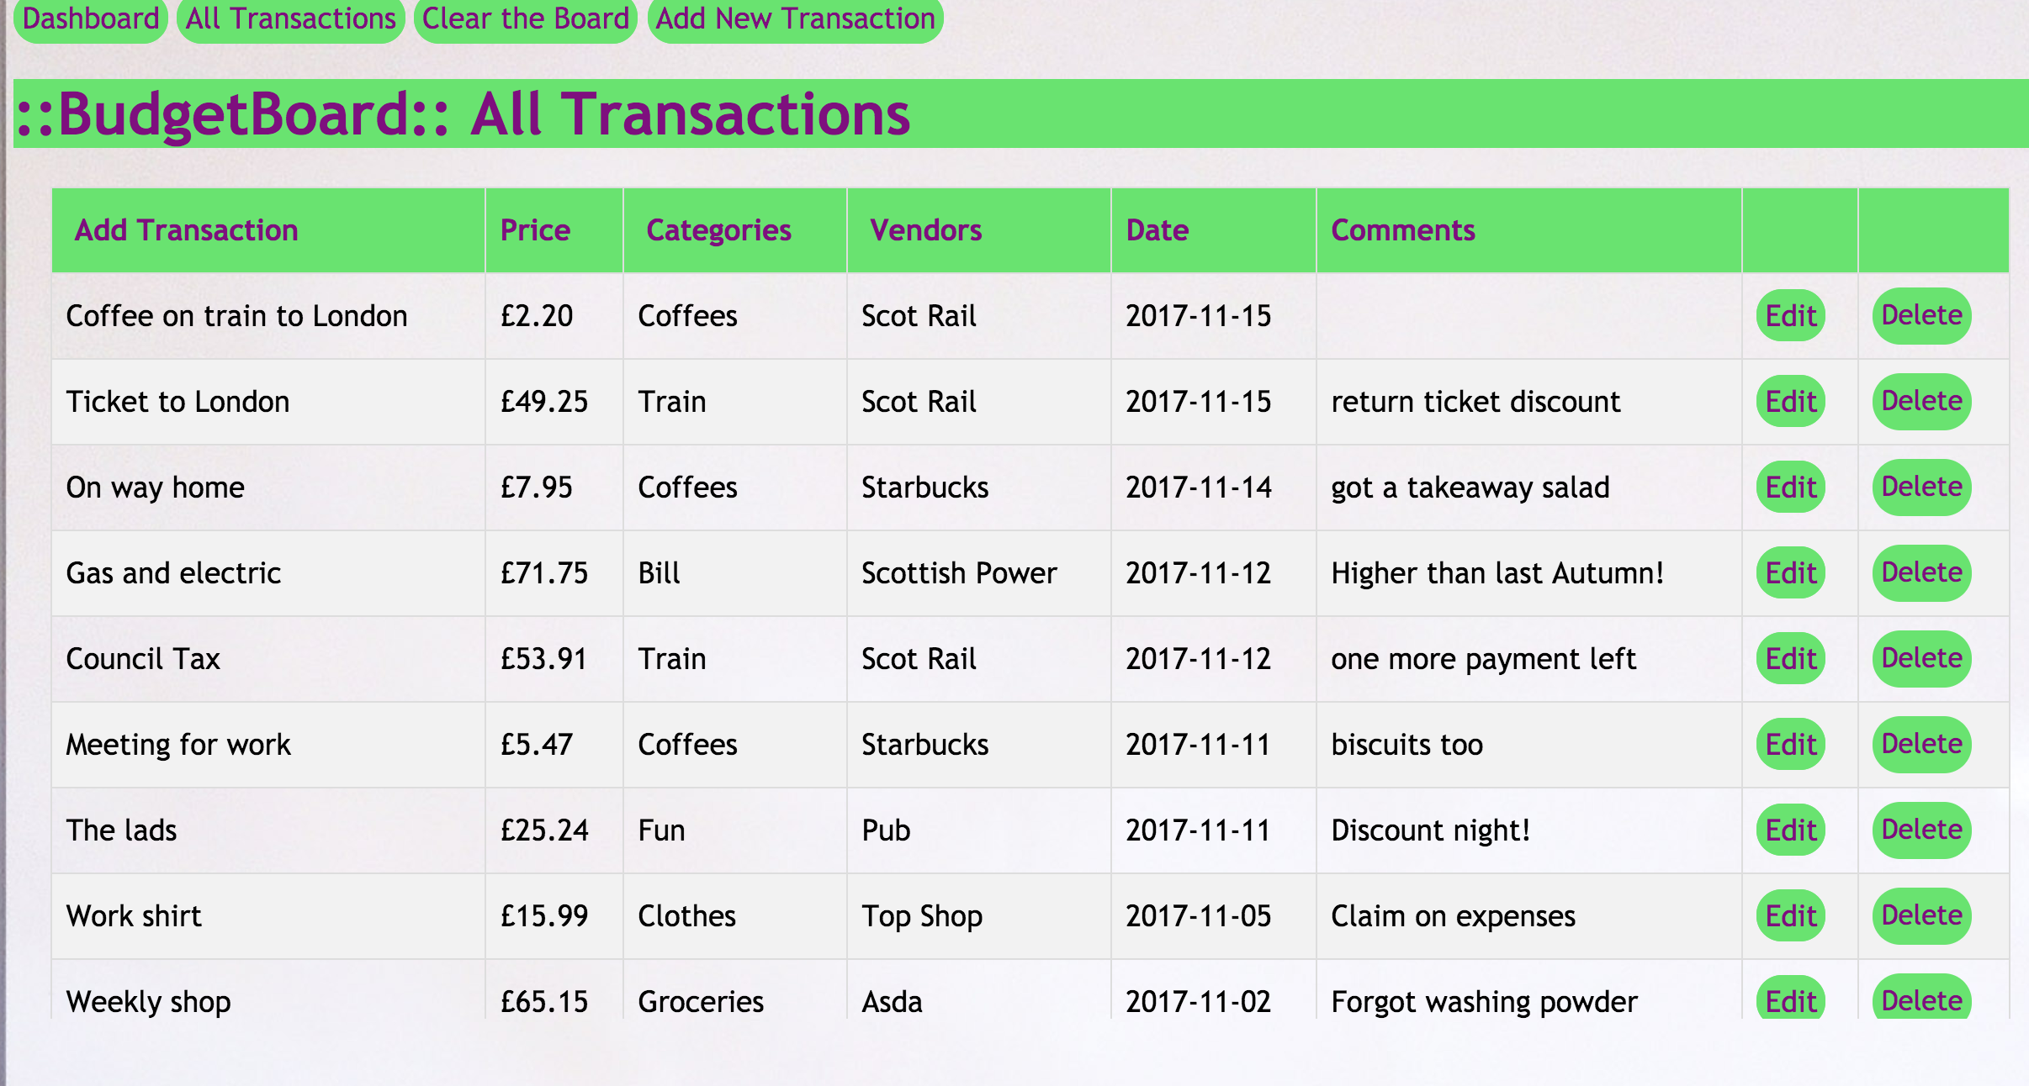
There are many transactions in the database.

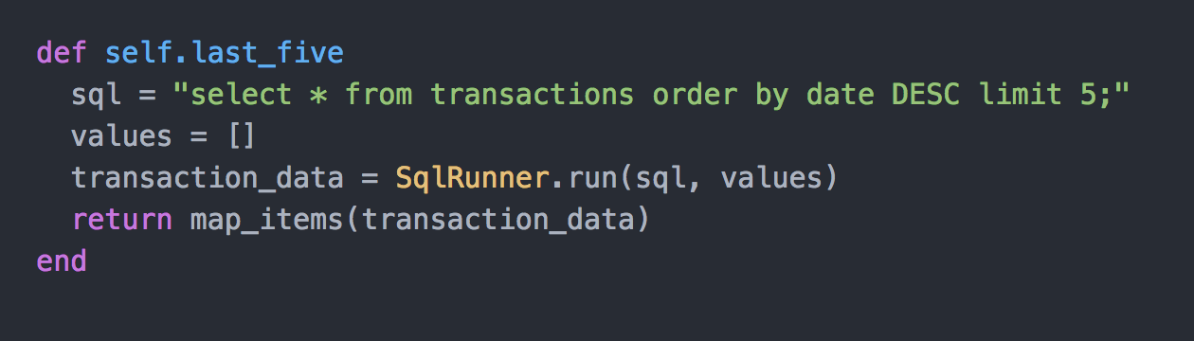
I apply a search for the last five transactions.
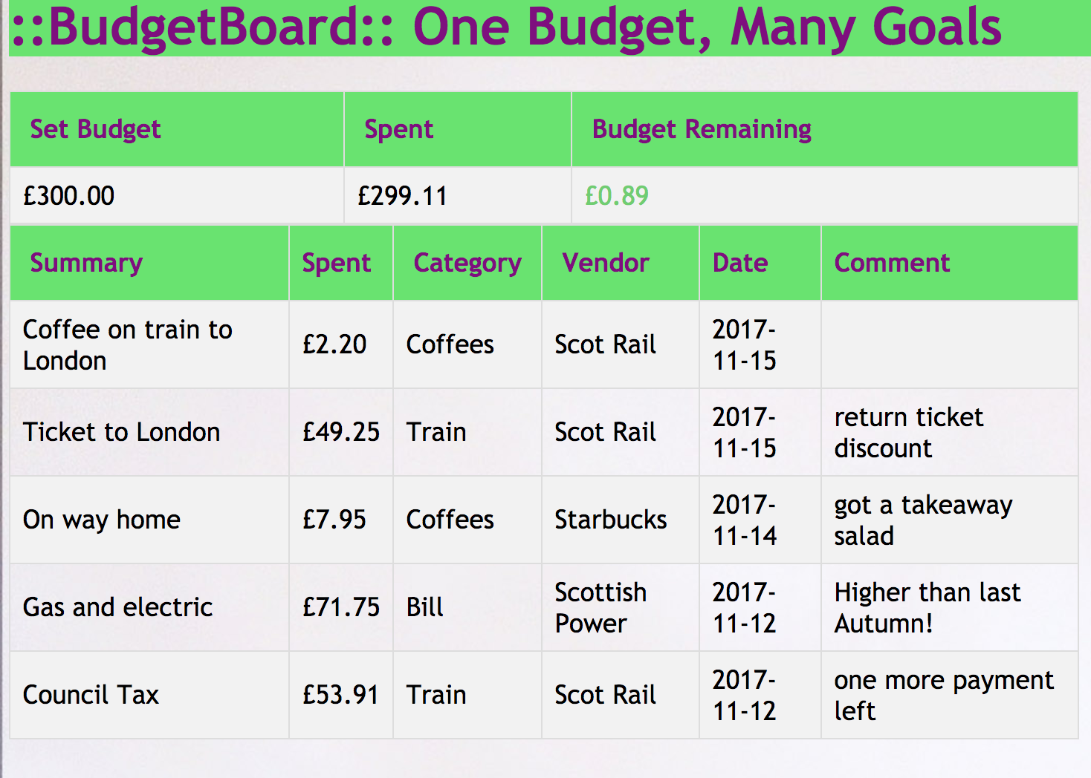
The last five are then displayed.

I.T 4

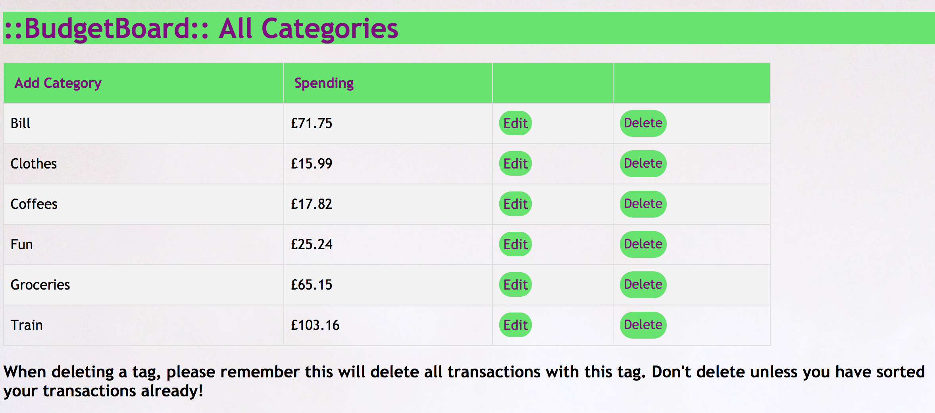
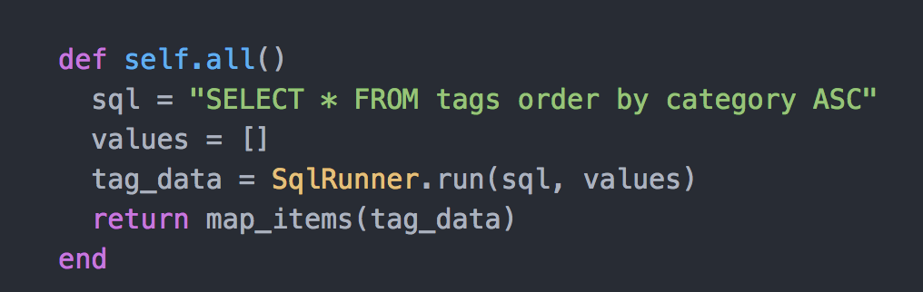
New tags can be added

They are sorted into alphabetical order when they are displayed by this sql query.

